# Creating a Wallet

Before you can start using the Megacapital.io platform you need to have an e-wallet. If this is your first time investing in Cryptocurrencies, let’s quickly set up the wallet to get you started.

BullPerks allows you to use any wallet that supports the WalletConnect protocol.

We will be using [MetaMask](https://metamask.io/) for convenience and simplicity.

Warning: Use ONLY the [official site](https://metamask.io/download.html) and Google Play / App Store app to install MetaMask.

1. Go to Metamask.io and click on Download Now
2. 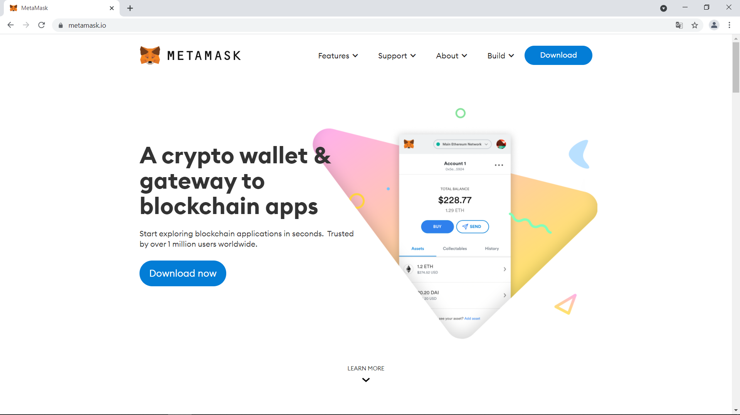

2. MetaMask will automatically identify your browser and offer an extension for it. In my case it’s Google Chrome, so I should click on Install MetaMask for Chrome.

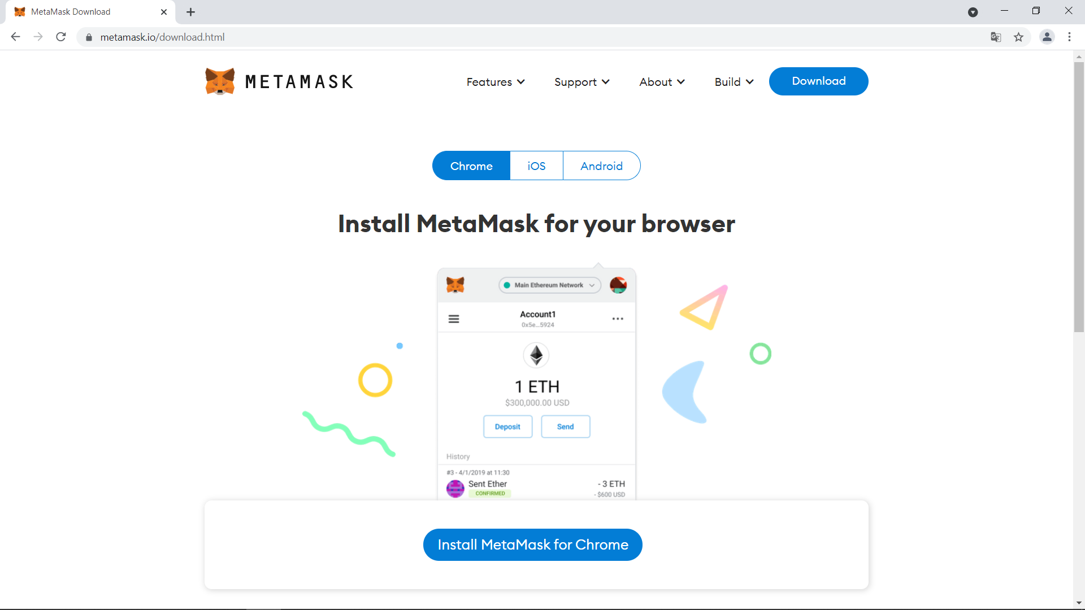

3. The link will lead us to the Chrome Web Store where we need to click on Add to Chrome to use MetaMask.

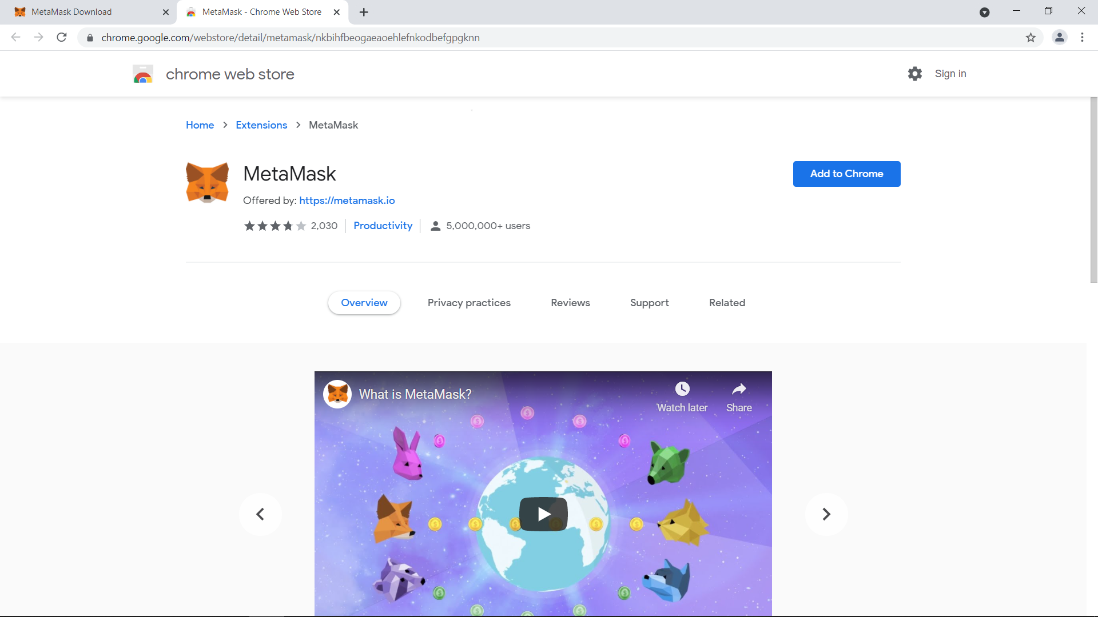

4. A small window will pop-up where we need to click on Add extension to confirm adding it.

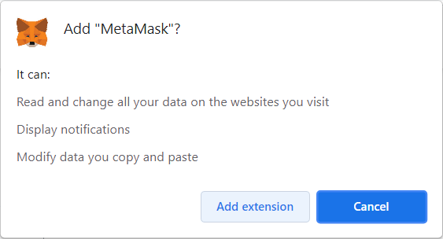

5. Once Google Chrome installs MetaMask, a window will pop-up to assist you with setting up your new wallet.

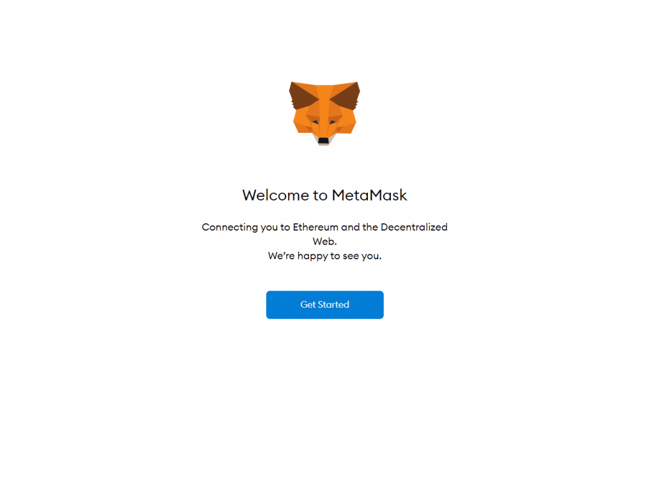

6. Click on Get Started and on Create a Wallet in the next screen:

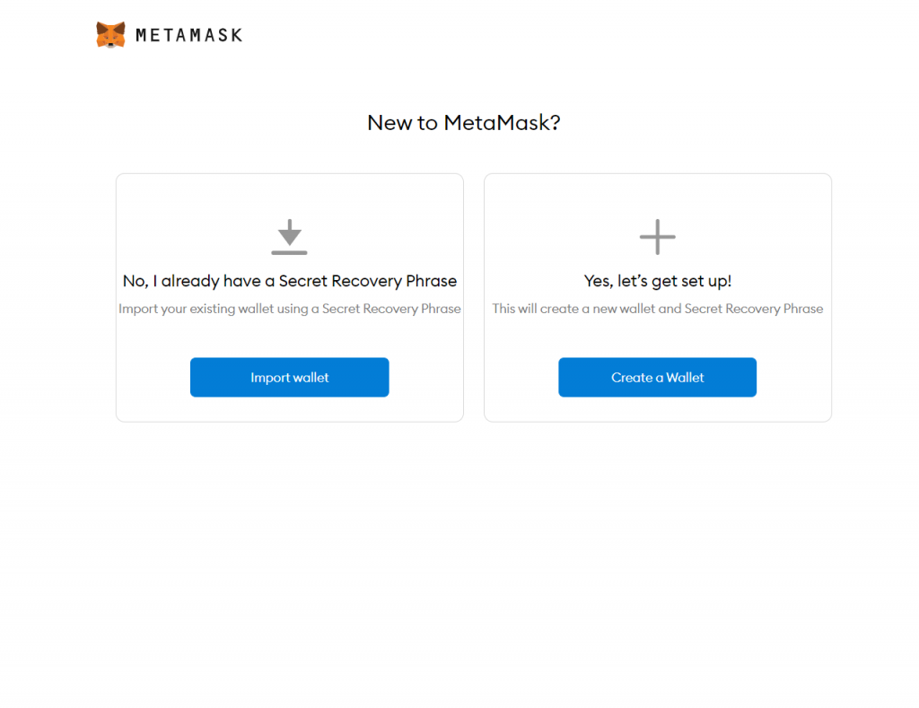

7. Opt-in or out of collecting data to continue creating your wallet.

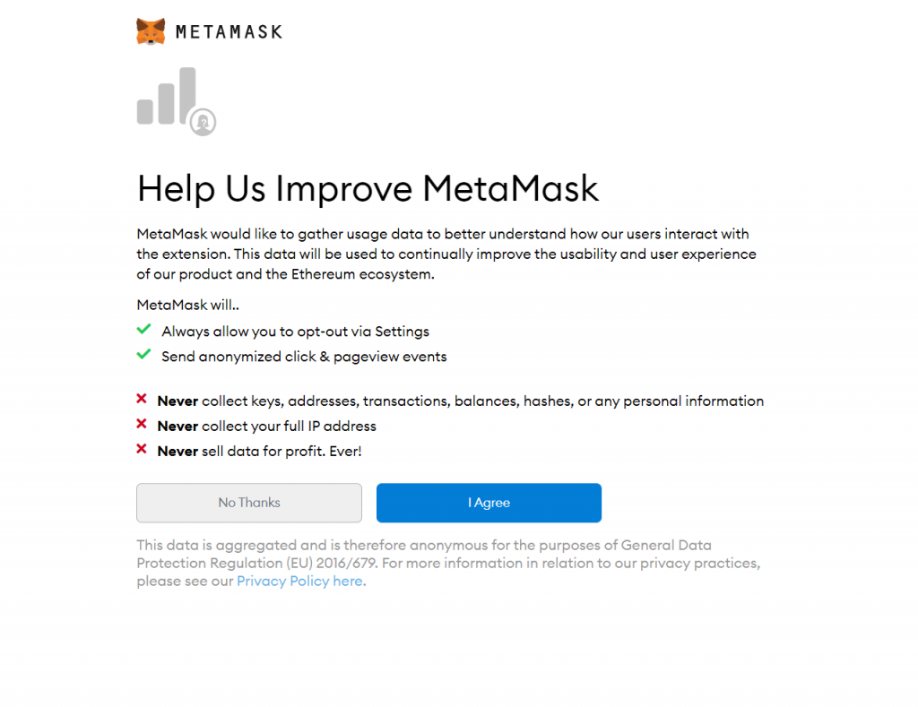

8. Choose a unique password, agree to the Terms of Use and click on Create.

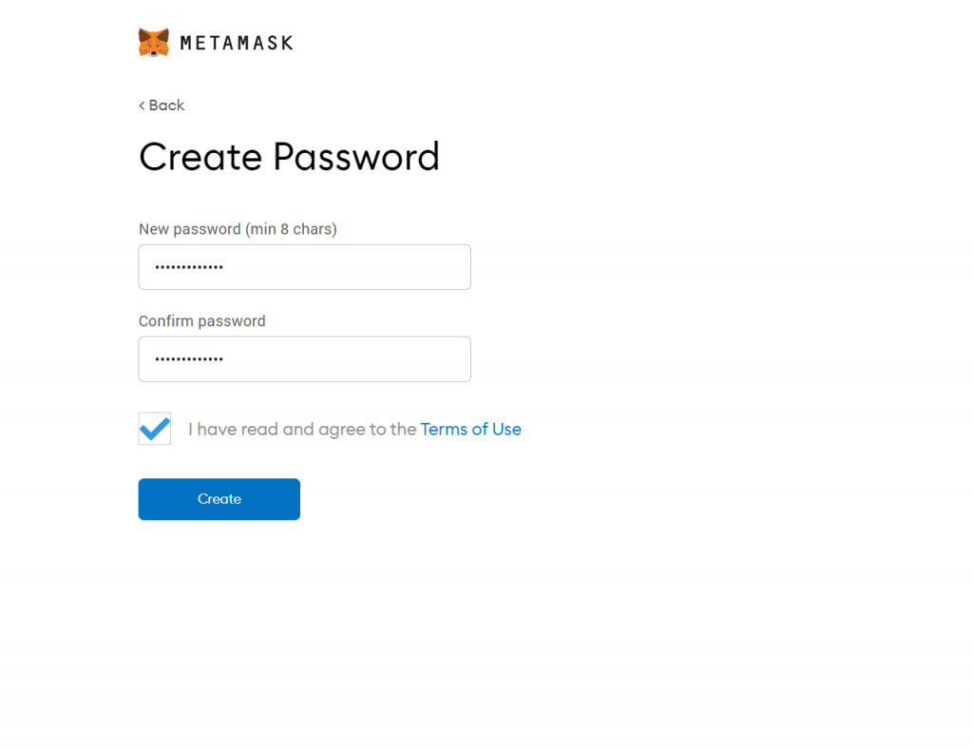

9. Next step is to secure your wallet in case you forget your password. In the cryptocurrency world, there is only one way to restore access to your wallet and it’s using a recovery phrase. Click on Next when you’re ready to record your recovery phrase.

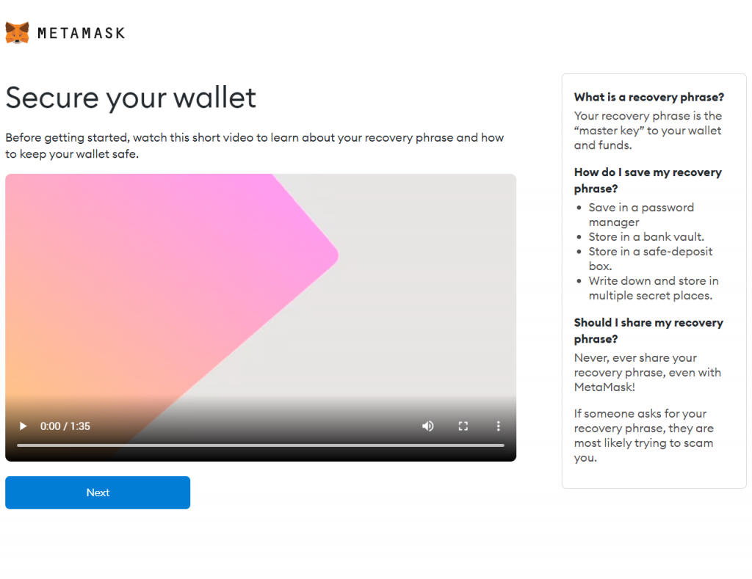

Warning: Megacapital.io will NEVER ask you for your recovery phrase!

10. On the next window, you must click on the blurred area to reveal your secret words.

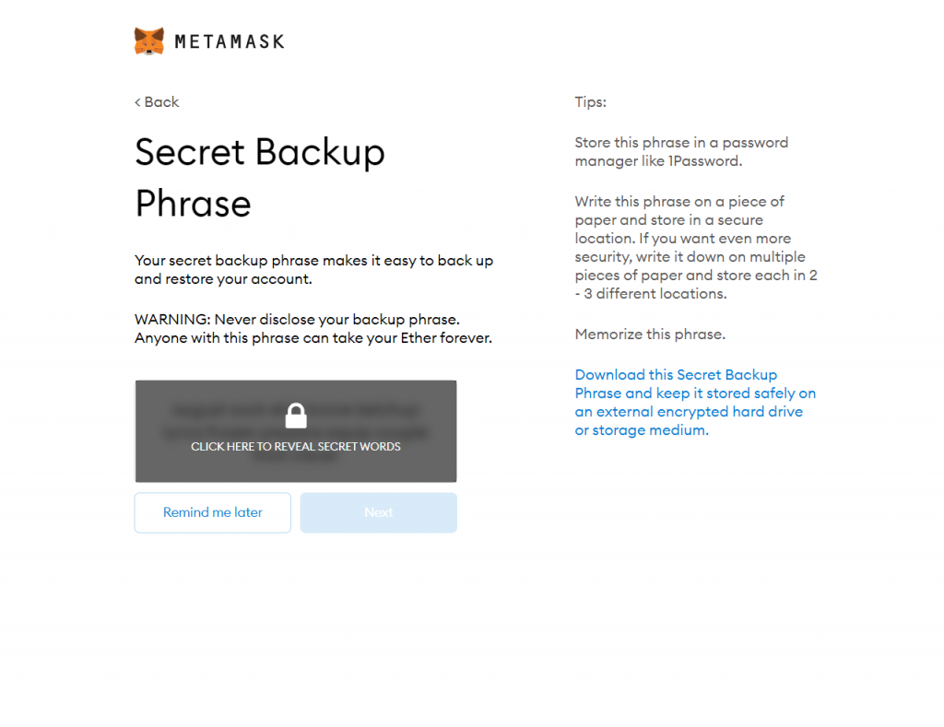

The recovery phrase consists of 12 words which are given in a specific order. Memorize or write down the words in this order somewhere secure and click on next:

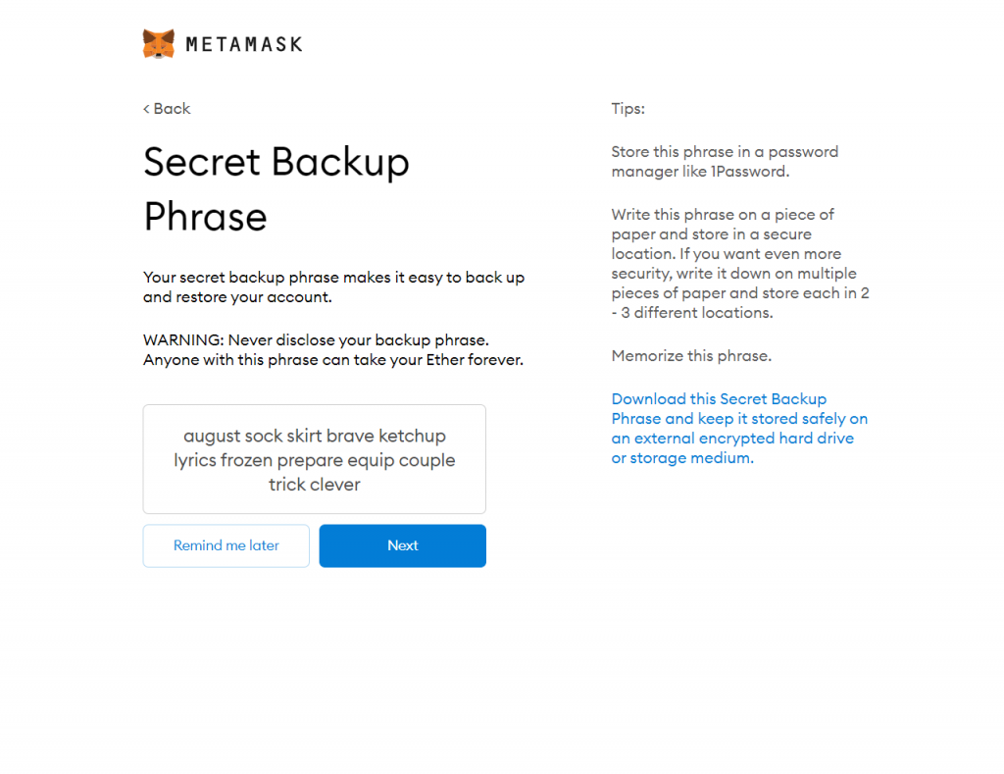

11. In the next screen, MetaMask will ask you to confirm your recovery phrase. To do that, click on the words in the right order one by one until you have formed the phrase and then click on Confirm.

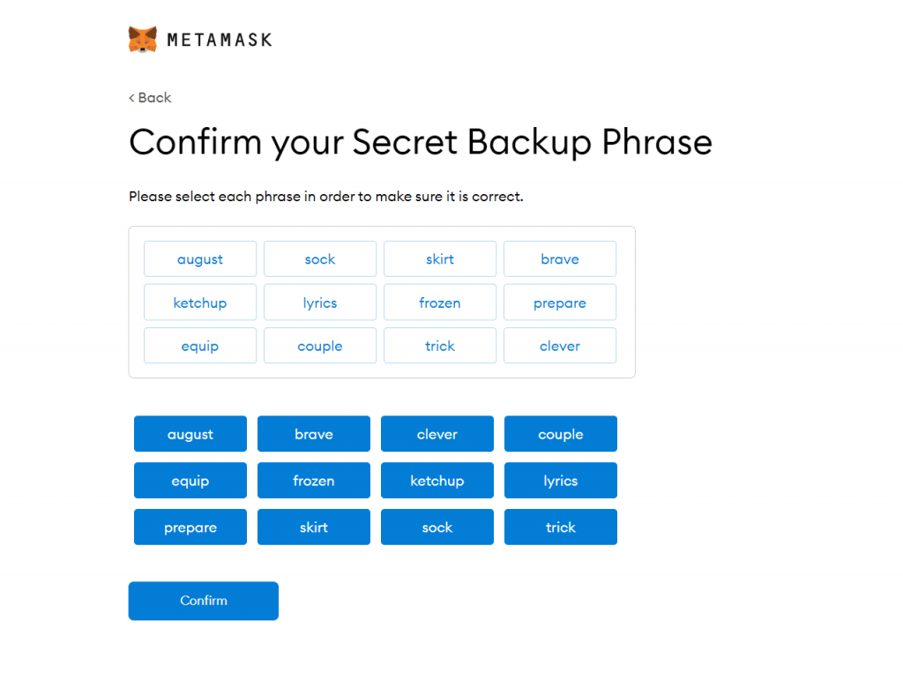

12. Congratulations. You have now created a new wallet!

